Lab- Creating a Virtual Private Network

*What is a VPN ?*

A VPN (Virtual Private Network) is a network that establishes a secure and encrypted connection between two points by creating a tunnel through a public network like the Internet. It allows users to protect their online activities and data by routing the data traffic through a secure server and masking the user's IP address. VPNs are commonly used to ensure privacy and anonymity on the Internet and to enable access to geographically restricted content.

* Using a Virtual Private Network (VPN) can be beneficial in various scenarios. Here are some situations where it's advisable to utilize a VPN:

When connecting to public Wi-Fi networks (e.g., in cafes, airports), a VPN encrypts your internet connection, protecting your data from potential hackers or eavesdroppers.

If you want to enhance your online privacy, a VPN can mask your IP address and encrypt your internet traffic, making it more difficult for websites and online services to track your activities.

Bypass Geo-restrictions:

VPNs allow you to access content that might be restricted based on your geographical location. By connecting to a server in a different country, you can access region-locked content.

For remote workers, a VPN provides a secure connection to their company's network, ensuring that sensitive business data is transmitted securely.

In countries with strict censorship laws, a VPN can help users bypass these restrictions and access blocked content or social media platforms.

When conducting online transactions or accessing sensitive financial information, using a VPN adds an extra layer of security to protect your data from potential threats.

If you engage in peer-to-peer file sharing or torrenting, a VPN can hide your IP address, providing anonymity and protecting you from potential legal issues.

Some internet service providers (ISPs) may throttle your internet speed based on your online activities. Using a VPN can help avoid such throttling.

*Purpose of this Lab*

* Utilizing a Microsoft Azure Virtual Machine, I will gain access to a VPN utilizing the VPN Proton software. Doing this lab will show how gaining access to a VPN will give you that extra layer of security. You will see how accessing one will put your network in a completely different region with a new IP Address.

(Visual explanation of how a VPN works and gives your network an added security.)

1. Browse to https://whatismyipaddress.com/ on your computer and take note of this in a text file.

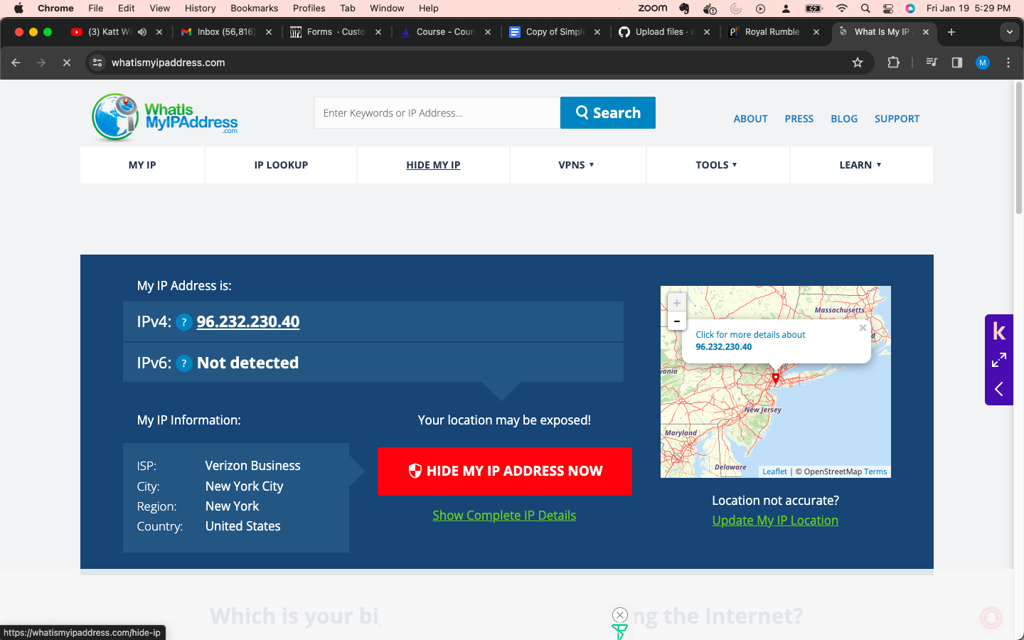

(IP address on my personal physical computer)

1. Create a Resource Group and then create a Windows 10 Virtual Machine in another geographic location (try a different country). Log into the VM with Remote Desktop.

(The creation of the virtual machine and me booting it up through the Microsoft remote access)

1. Browse to https://whatismyipaddress.com/ and take note of this in a text file.

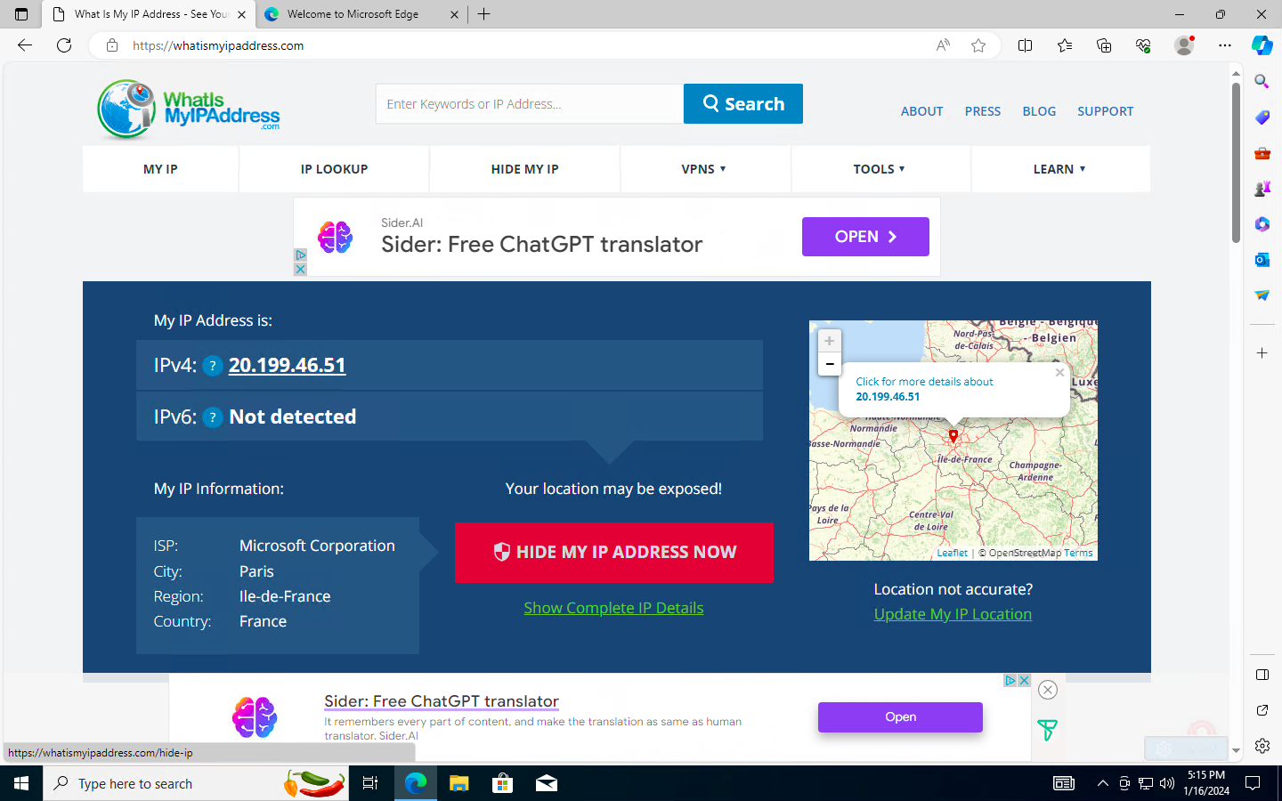

(This is the VPN for the virtual machine I created using a European region)

1. (Sign up for ProtonVPN and test the VPN connection)

On your actual computer, sign up for the free version of Proton VPN https://account.protonvpn.com/signup?plan=free&language=en and then back within your VM, download the Proton VPN client.

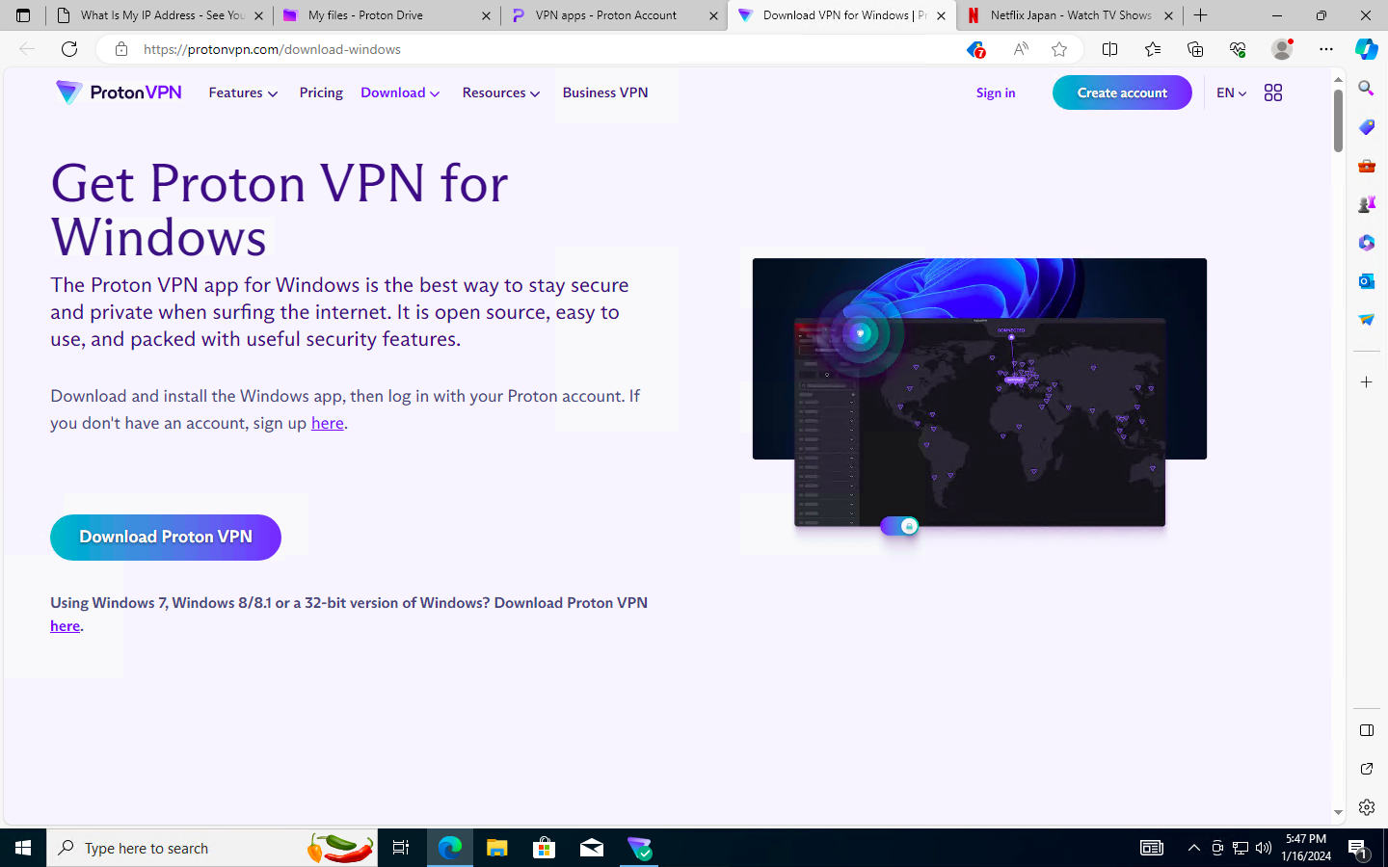

(This is the Proton VPN webpage. Download the software from here on the VM)

1. Login to the VPN and choose a VPN server in yet another country (such as Japan)

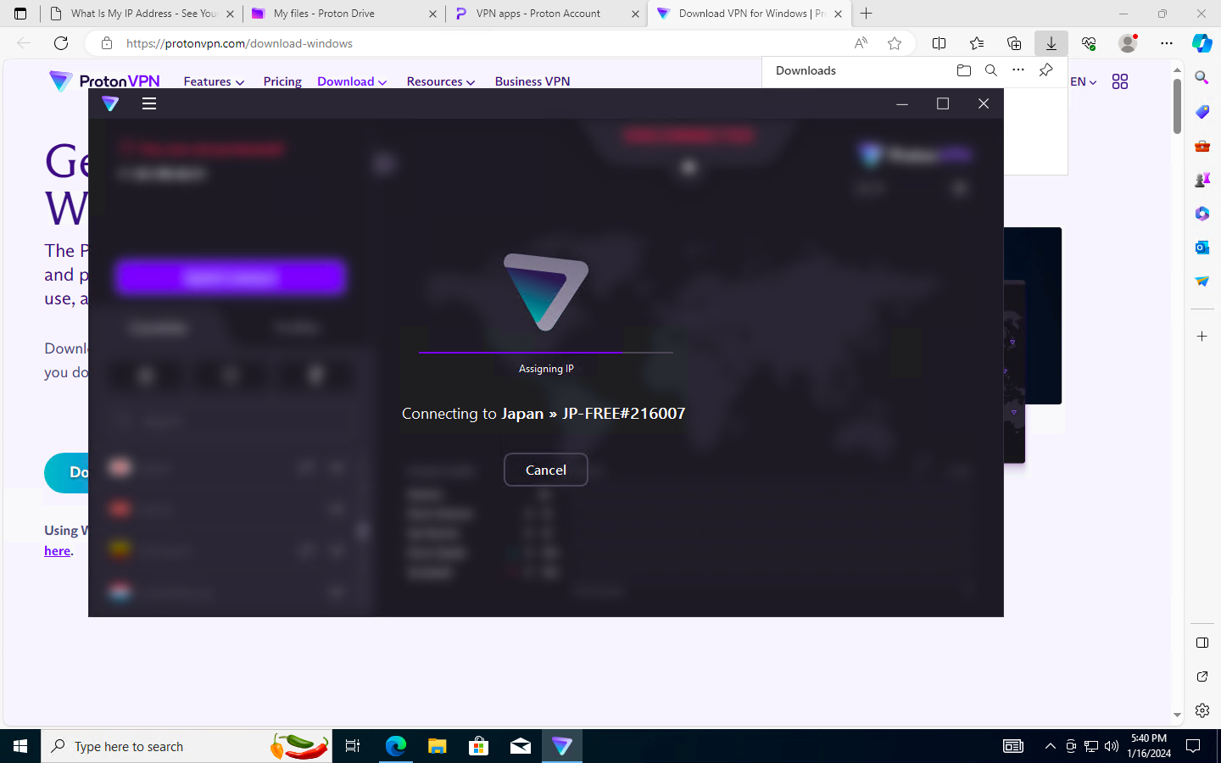

(I’m connecting to a server in Japan)

1. Browse to https://whatismyipaddress.com/and take note of this in a text file.

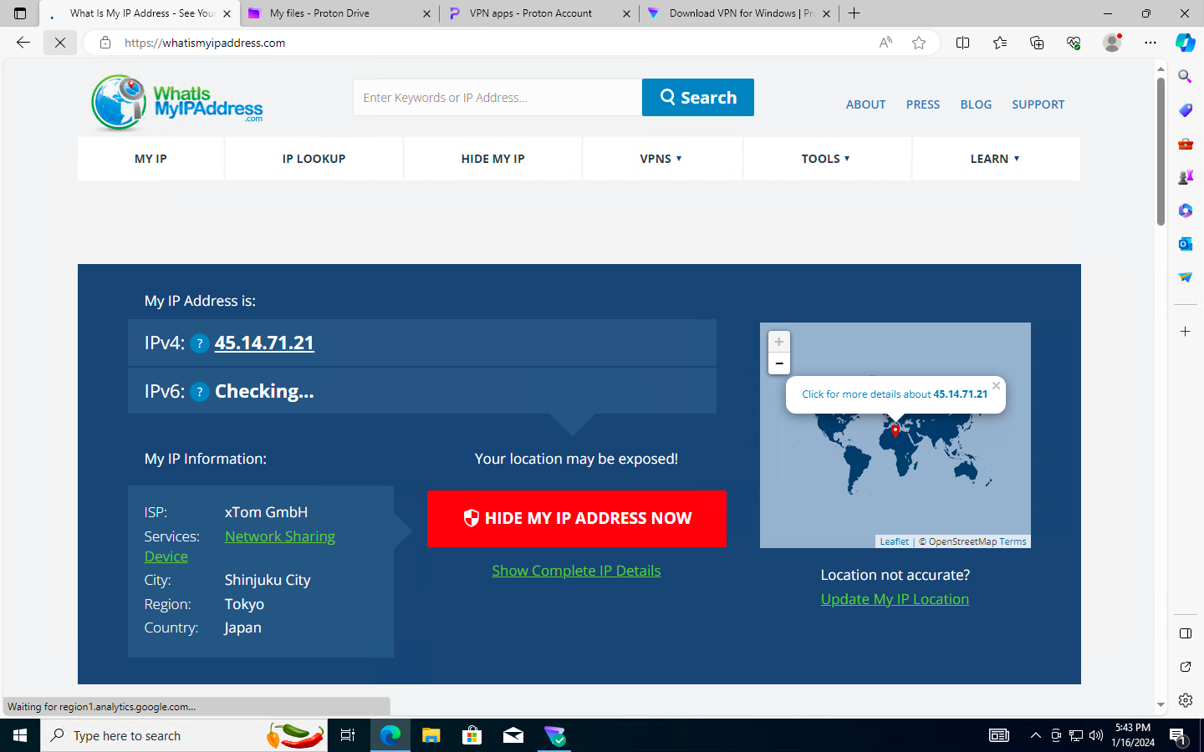

(This is the IP address for the VPN in Japan)

1. Try browsing to Google, Disney, and/or Amazon and see if there is anything different about the sites in relation to the location of your VPN server. For example, the language or URL may be different.



(This is the Japanese version of Netflix through the VPN connection)

1. (Clean up Azure resources) Ensure the resources/Resource Group has been deleted.